# **Chapter 1: Introduction**

Online food home delivery system is web application which helps to create online food order and delivery pathway between the customers and restaurant. With the increasing popularity of the food home delivery services this project may be and update or option to the traditional telephone food order system. Food home delivery system is online food ordering system used by a restaurant to facilitate the user to order the food online and get delivered. The main objective of this project is to help the business expand its business online by providing online delivery service to the customers.

Using this system restaurant can receive the order and provide the delivery of the order. Here user can use the internet for the food ordering process and restaurant can easily schedule the order delivery within a short time.

## **1.1 Background of the project**

Food home delivery system is a system which allows the user to register and login to the system in order access the online food home delivery system of a restaurant. Here they can select the foods accordingly and place their order online. User can view the food details, their review and comments and order the food according to their taste and preferences. They also will be able to order a multiple item and can get the total calculation of their order instantly. Their register and login details will help to assure their identity for ordering and delivery of the food.

This system helps the restaurant to track the online ordering and provide the instant delivery to the user ordering the foods. Here the restaurant also can allocate the delivery staff according to the order received. There are many types of online food home delivery website that exist already. Many of the features can be similar to the web-application found in the market. The main objective of this project is to provide high quality user experience.

Here in order to create the project PHP has been used as programming language under the Laravel framework for the design and code. And project libre to manage the milestone of the project.

## **1.2 Problem Statement**

This project is to create online food home delivery application that focus on the current market i.e. Nepal market. Nepali market will be the main focus as a decent web application are usually developed outside the market. This application will be improved version of the current application found in the market. It will also help to overcome the inefficiency faced by both the customer and the restaurant. Different inefficiency can be faced using the traditional food ordering system regarding the cost, time and quality services. This project will be solving the inefficiency of both the customer and the restaurant using this system. Restaurant business also can be improved through the automation of the business process and stand out from the competitors in a very competitive business environment.

## **1.3 Features**

* **Ordering:** User can order foods from any place
* **Feedback**: User can provide feedback
* **Multiple ordering:**  Different foods and services can be order at one time
* **Profile Management:** Restaurant can upload their menu in the portal
* **Bill Generation and payment**: Cash on delivery and bill generation
* **HR Management:** Control staff and their shifting
* **Customer support**: support to the customer regarding any problems faced can be provided
* **Delivery scheduling**: Scheduling of the delivery route and the staffs can be managed
* **History:** User can order through their own order history
* **Review Feedback**: Restaurant can see reviews received from the food

## **1.4 Aims**

* To provide fast and convenient food order and delivery system for both the customer and restaurant
* To provide customer the facility of order different items of food at one time
* To provide restaurant the online portal to gain the online customer and cost-efficient food home delivery

## **1.5 Objectives**

* To analysis the current problem faced and provide better solution and implementation of the system.
* To design a new web-application with user friendly environment with different features.
* To implement the analysis and design properly and code in a possibly best way
* To test the web-application being designed in order to increase the efficiency and performance of web-application.
* Each step during the development phase must be tracked.
* To document the all the features and report of the web-application.

# **Chapter 2: Analysis**

**Introduction**

Analysis is the process of detail examination of a project by breaking it into different parts in order to understand the nature, problems of a project or determine its essential features. It is the step where the requirement and prototype for the system is defined by gathering, analysing and validating the information. Requirement gathering is the first step under the analysis where all the requirements are gathered and further broke down into functional and non-functional requirements with the MoSCoW prioritization. Different diagrams such as use-case, rich picture, initial class diagram etc. are used to describe the analysis phase.

## **Requirements**

**Functional Requirement:** Functional requirement defines of a system or its component, where function is described as a specification of behaviour between outputs and inputs.

**Non-Functional Requirement:** Non-functional Requirement specifics criteria that can be to judge the operation of a system rather than specific behaviour.

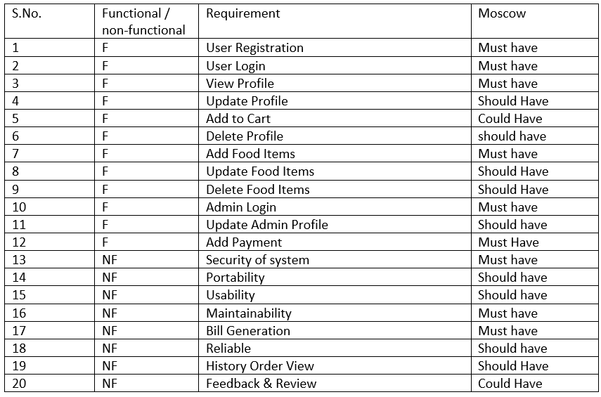

## **Use-Case Diagram**

Use case diagram is considered as a behavioural diagram basically used to describe a set of actions performed by the system in collaboration with one or more external actors.

**2.2.1 Login and registration use case**

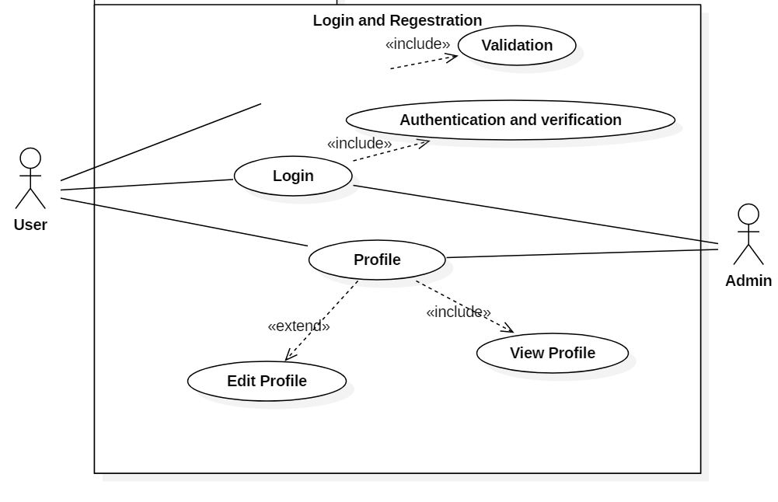

**Explanation:**

Here for the login and registration two types of user interacts with the system. Both the users are provided with different privileges i.e. admin and user. User fill out the registration and clicks on register button and the system validate the information provided by the user to register the user successfully. They can access the system providing the email and password. In the case of the admin they can directly proceed to login with in the verification. For the authentication system will use email, password and user type. In case of successful login dashboard of each will be displayed and if unsuccessful error message will be thrown. On the successful login user can view and edit their profile. They can log out of the system.

**2.2.2 User use case diagram**

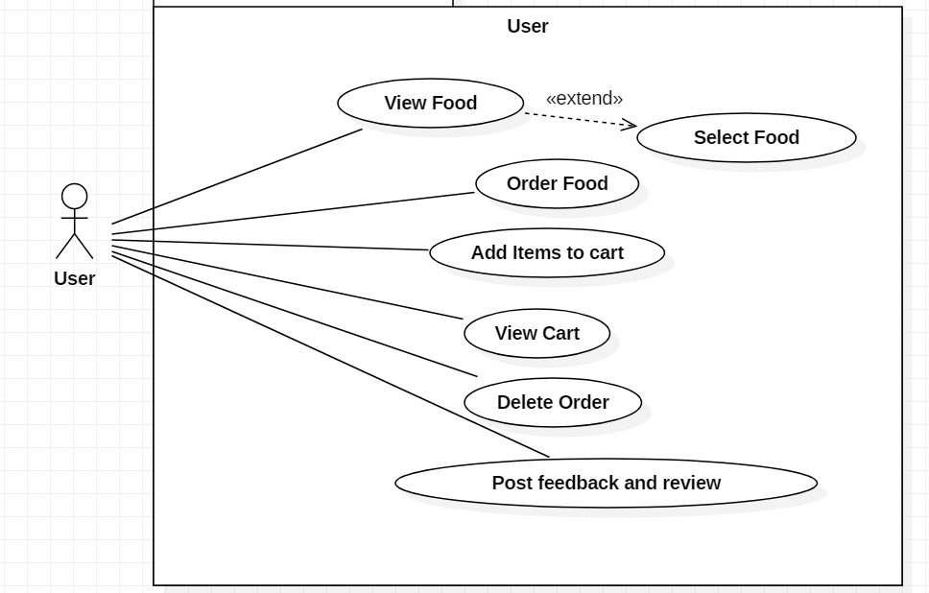

**Explanation:**

Different privileges have been provided to the user which includes view food, order food, add items to cart, View cart, Delete order, Post feedback and review.

User can view the food within their details, price and category. They can select those food and can place the order. They also can select different food items and can add the products to the cart and view the products added in the cart. When the order and the product is displayed in the cart, they can remove the product.

**2.2.3 Admin use case**

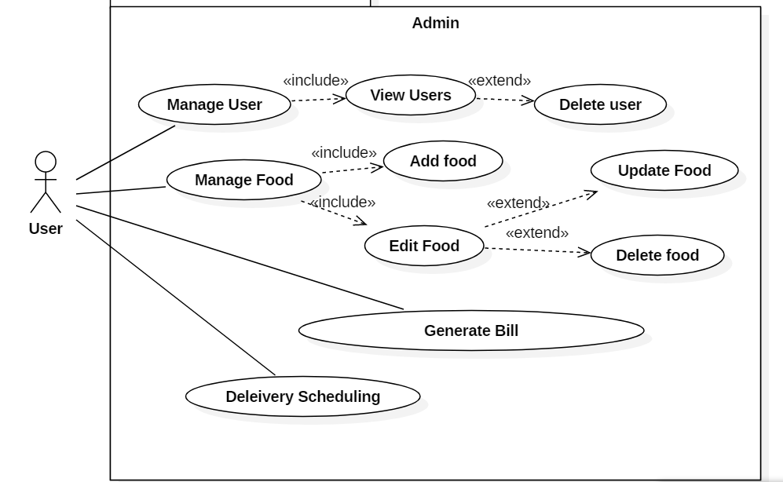

**Explanation:**

In the above diagram admin privileges are shown which is high as admin will be managing the products, user, order and bills. Here admin will be able to view the user registered to the system and can delete the users. Admin also will be able to add, update and delete the product list and can manage the orders made by the users. After the products are ordered by the users admin will be able to schedule the delivery as per the order made.

## **Initial class diagram**

Class diagram is a static diagram which represents the static view of a system. It describes the structure of a system by showing class, their attributes, operations and relation between the objects. It is also considered as the blue print of a system. Basically, the classes defined in the initial class diagram which is drawn during the analysis phase should be included in the final class diagram.

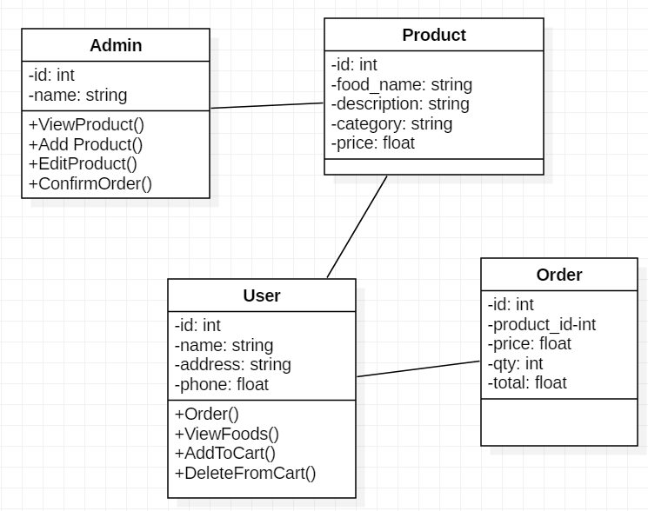

**Justification**

Different classes have been included in the above class diagrams which includes the related attributes. The class included in the above diagram are as follows:

* Admin: controls the action of overall system and process the outcome of the system
* Product: used to show the potential user the system view
* User: user will be able to use the system and interacts with the system
* Order: used for the final calculation and implementation of the user requirement in the system

## **Architecture**

It is overall structure of system which is responsible to handle functionality and quality requirement. For system architecture, functional and non-functional requirements are identified to the developers.

### 2.4.1: System Architecture:

MVC architecture have been followed in order to develop the project. MVC separates the system into Model, View and Controller where:

* **Model:** Represents an object and has logic to update controller if its data is changed
* **View:** Represents the system graphically and contain visual of the data that module contains
* **Controller:** Acts on both the module and view. And also controls the data flow into model object and updates.

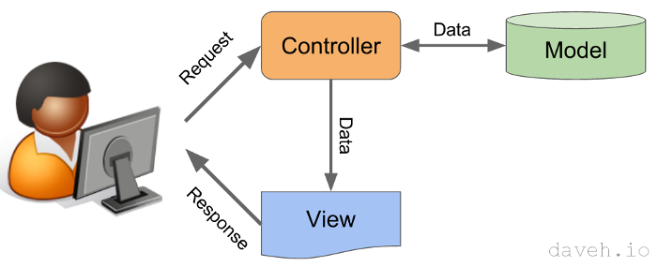

Figure 8: system Architecture

Advantage of MVC pattern:

* Supports rapid and parallel development which make development process fast
* Multiple view for a model van be created
* Entire model is not affected by the modification
* Team working is easy as multiple developer can work on one project
* Returns the data without any formatting

Disadvantage of MVC pattern:

* Increased complexity
* Knowledge of multiple technology
* Need multiple programmers
* Inefficiency of data access in view

# **Chapter 4: Implementation**

According to the SDLC after the completion of analysis and design, implementation should be performed. Implementation is the step where a real time working environment is created using the design that fulfil the client’s requirement. A programming language is chosen in order to convert the design into code. This step follows all the planning and design performed in the above phases. As a well coding helps to reduce the testing and maintenance effort of the system design should be implemented in a best way.

## **4.1 Language**

In order to develop the food home delivery system different kind of programming language can be used found in the market. So, as a developer I have to choose a language that I am familiar and have a knowledge about. As I have worked in a PHP programming language in my previous project, I have chosen the PHP programming language under the Laravel frame work which follows the MVC pattern.

PHP is an open source language which is free to use, and the code written under this language is easily understandable by a programmer. As it uses MYSQL for the database services which is also easy to manage and is relational database management system which have an advanced feature I have used MYSQL.

## **4.2 Developing environment**

I have used Laravel framework as web application frame work which basically works under the MVC (Model View Controller) design pattern. It is also an open source PHP web framework. Another reason to choose this frame work is because it is very fluent, user friendly and easy to learn. It also makes common tasks like authentication, routing, session, and caching easy for the smooth development process.

For the basic design of the system CSS and JavaScript has been used which is used to make the user interface and the layouts attractive

.

## **4.3 Deployment Strategy**

The process of implementing the project which includes installation, configuration, running, testing and making necessary changes in the user machine using the different tools and environment is known as deployment.

Windows operation system has been used in order to develop the project. And for the implementation of code and debugging VS code has been used which is then opened and tested in Google chrome and Mozilla Firefox.

# **Chapter 6: Testing**

T1

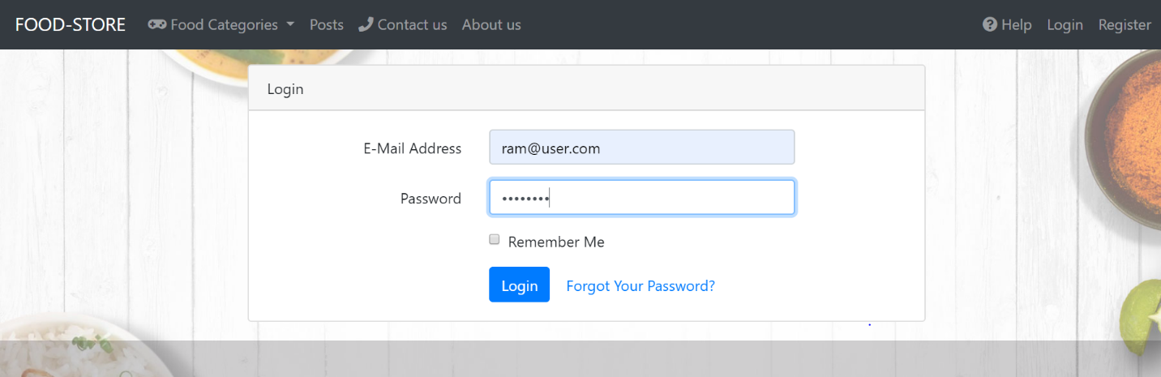

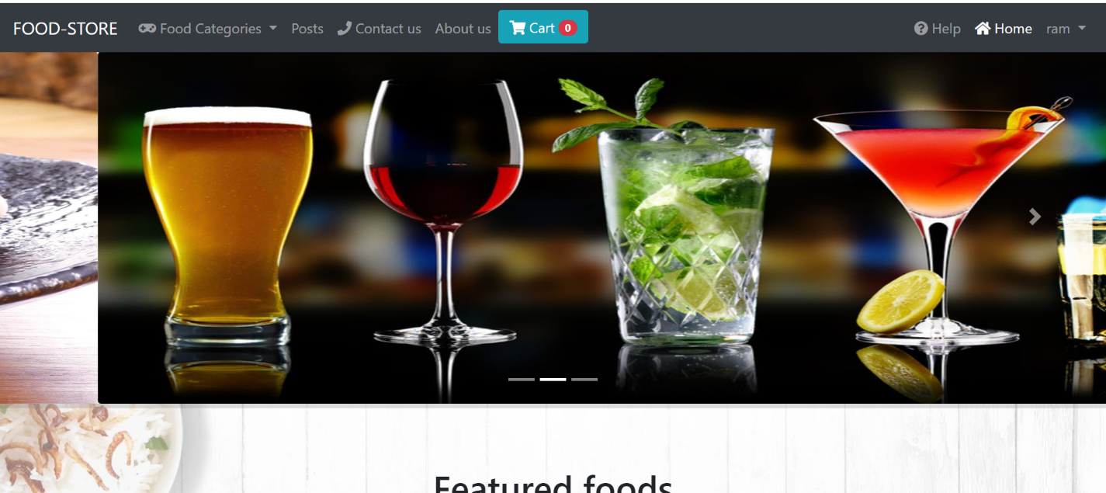

T2

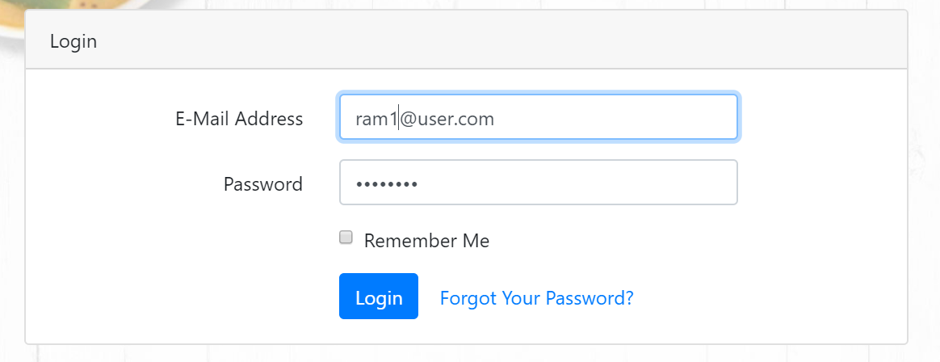

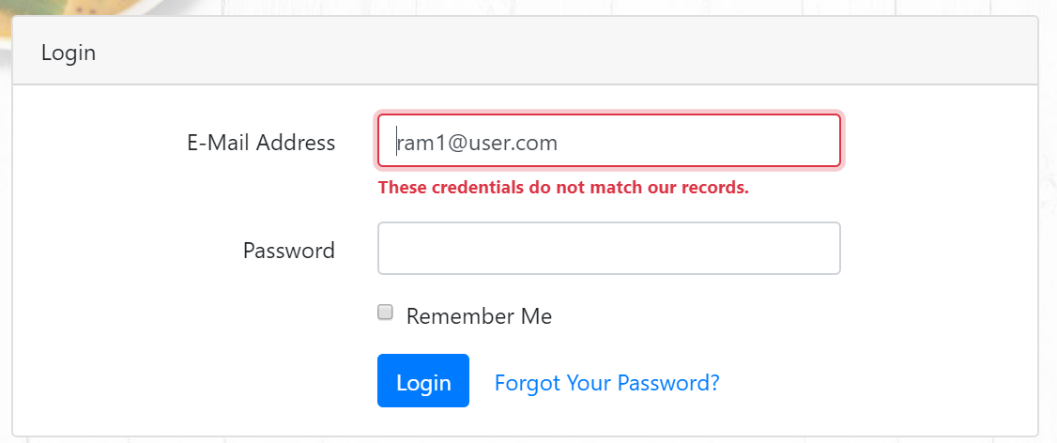

T3

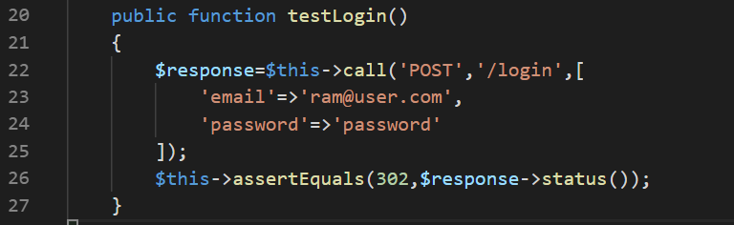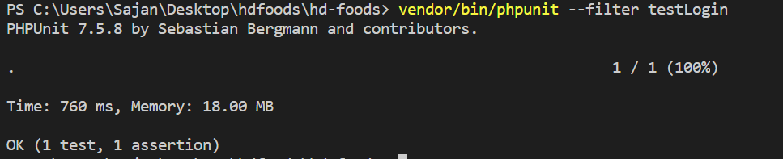

T4

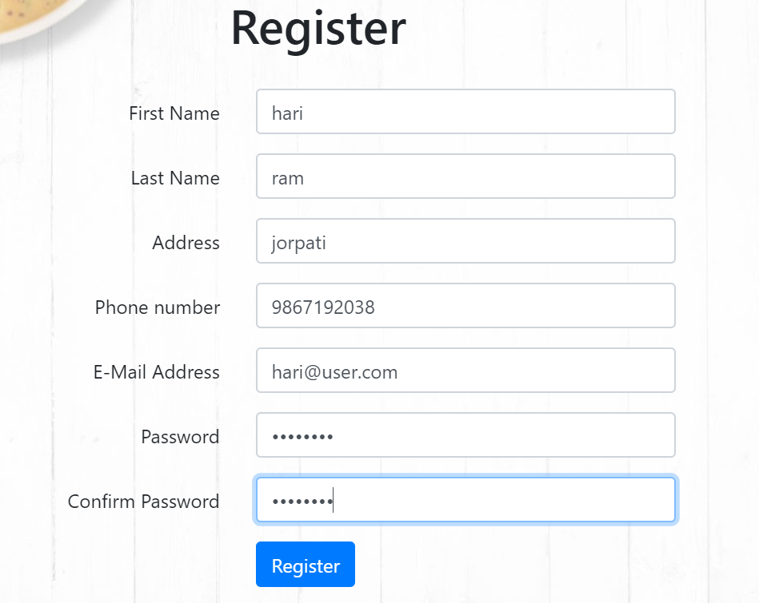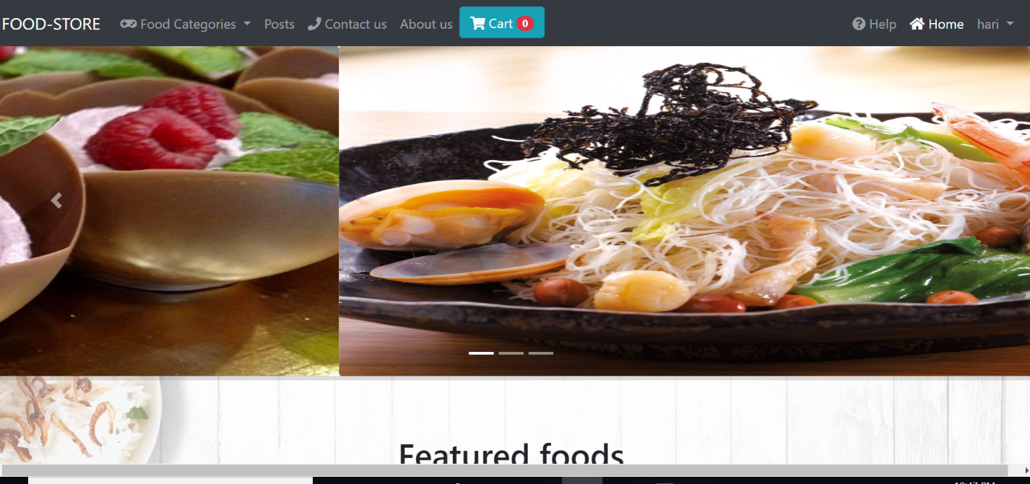

T5

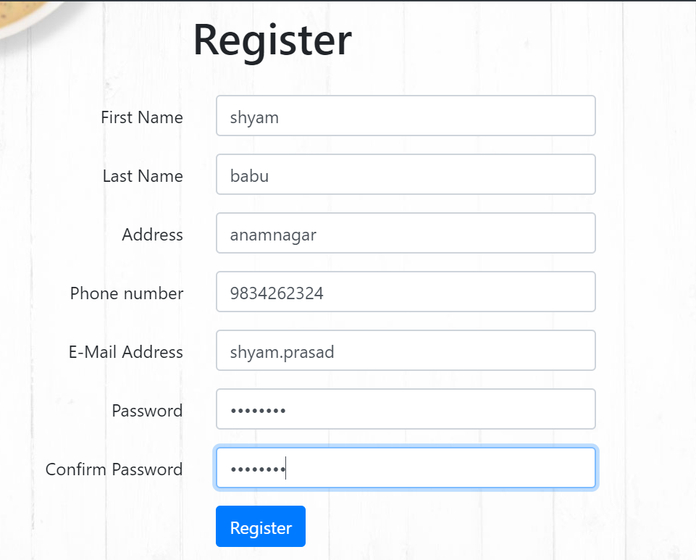

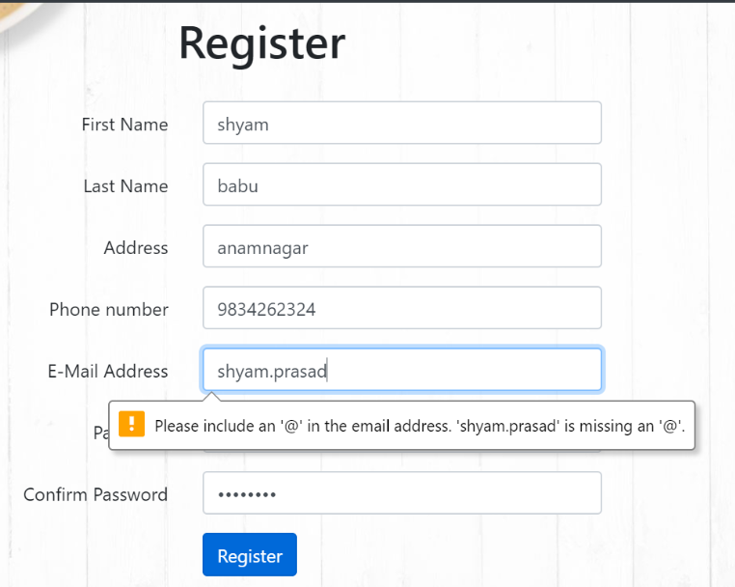

T6

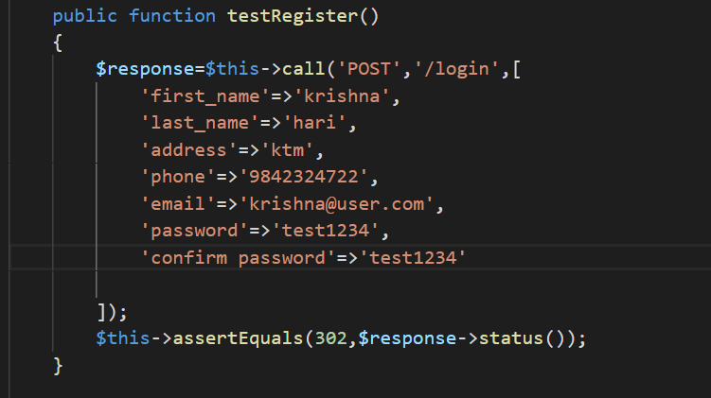

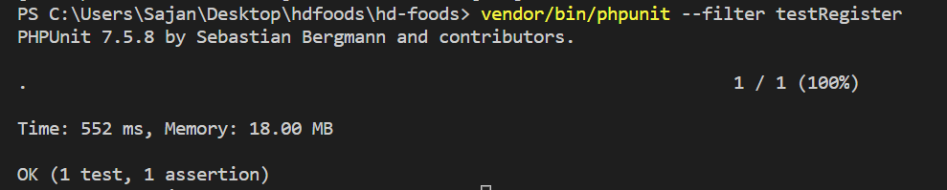

T7

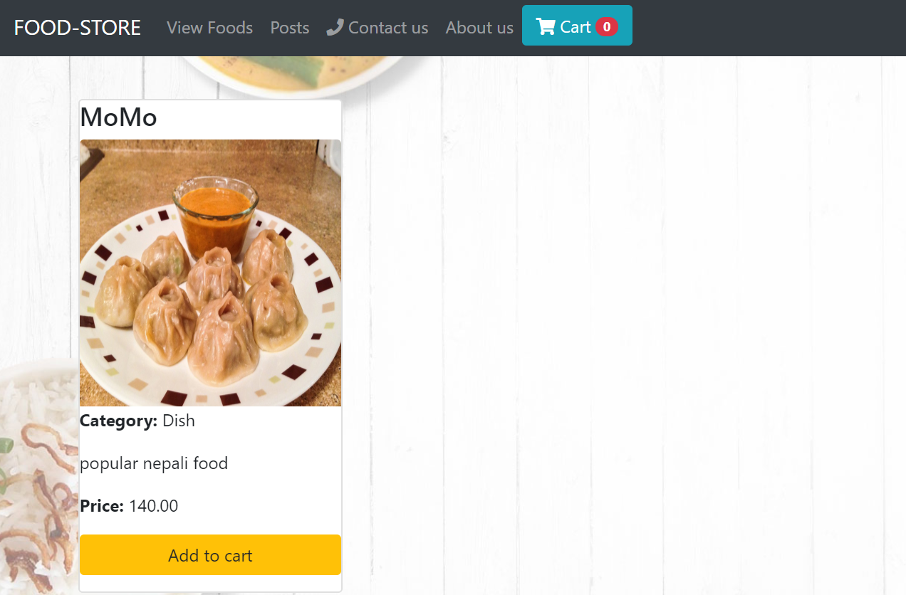

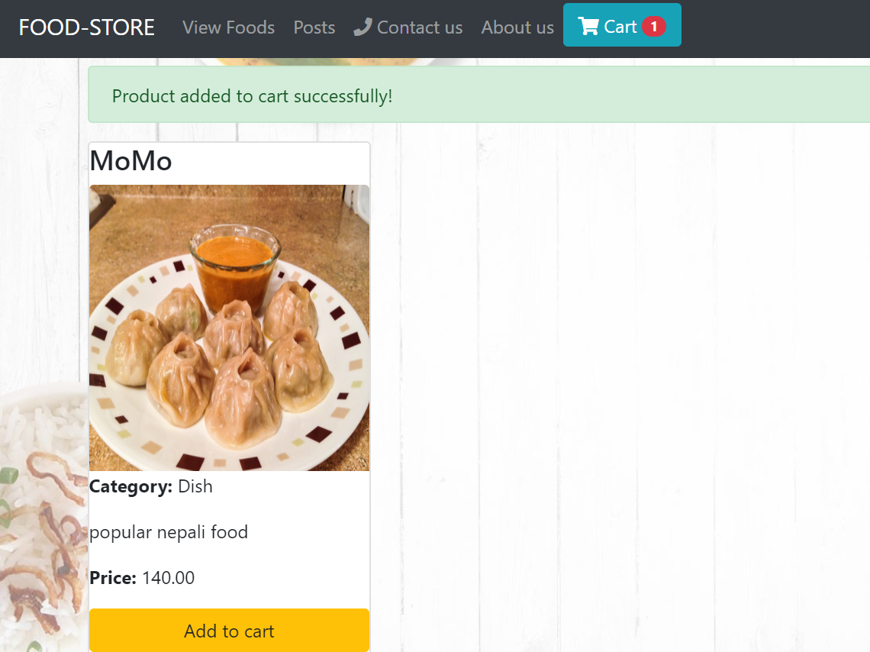

T8

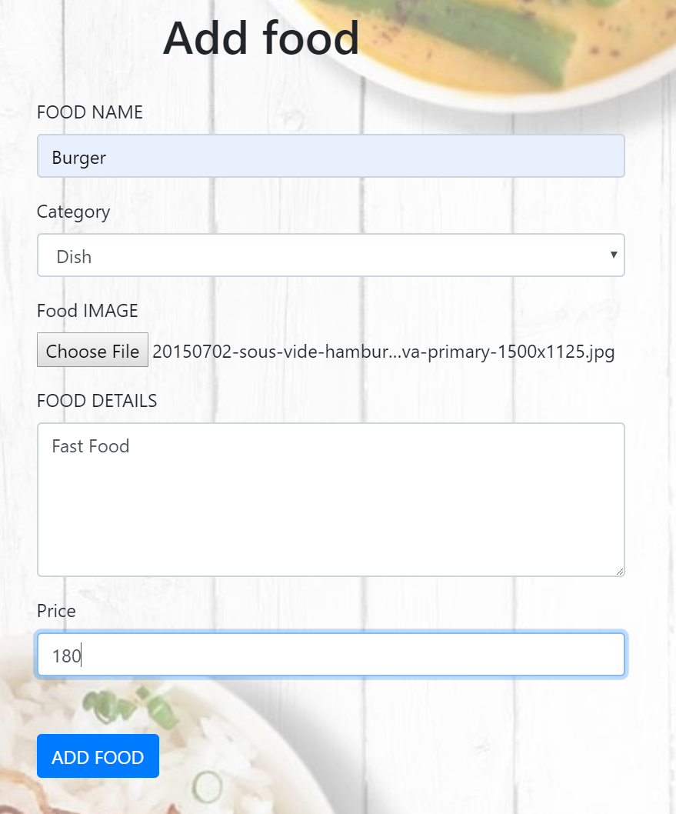

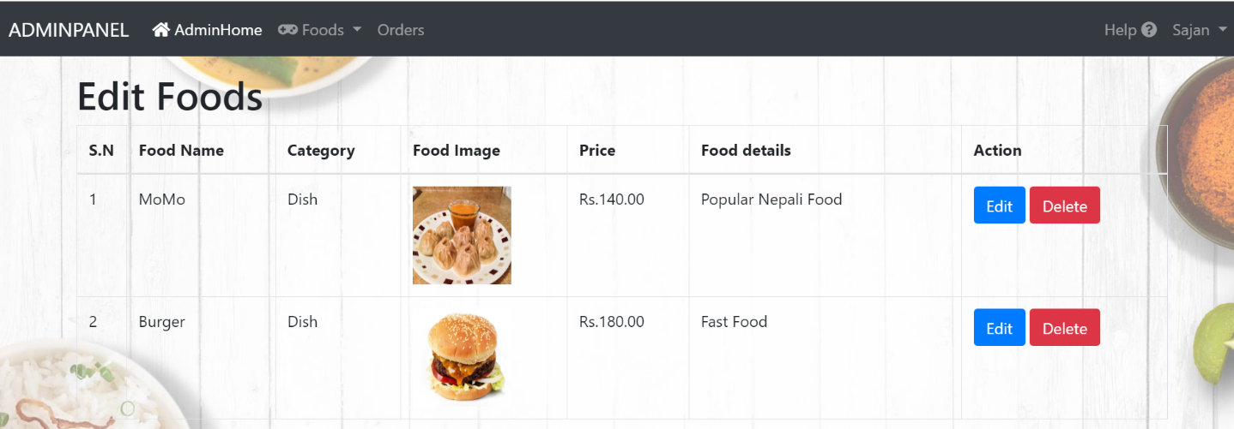

T9

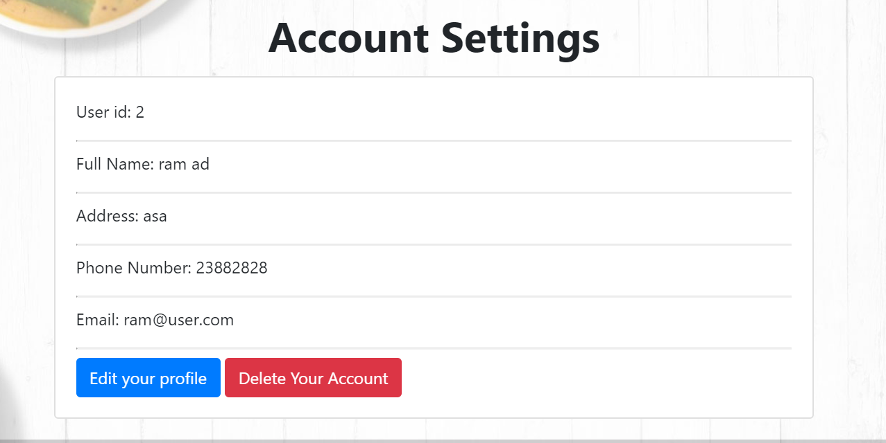

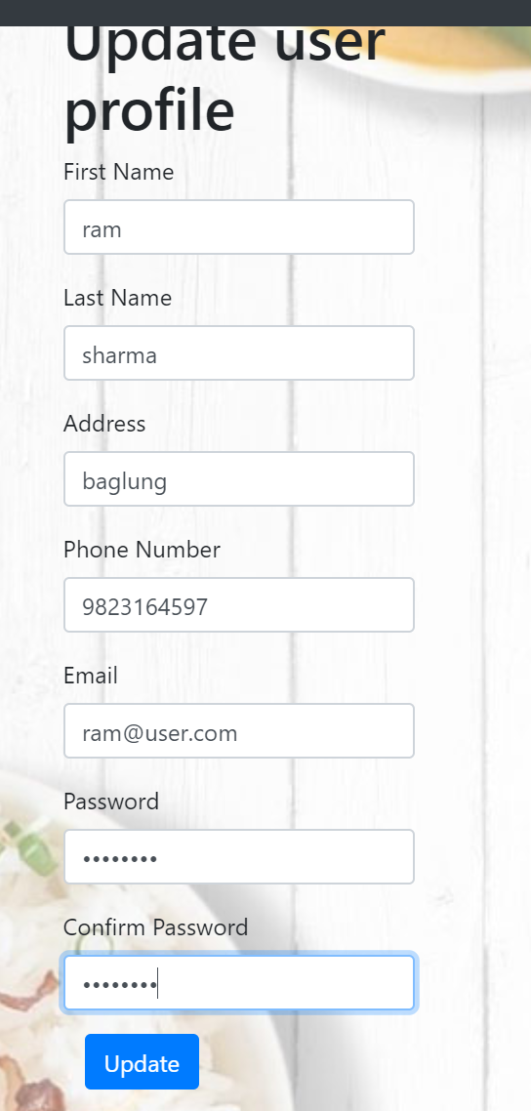

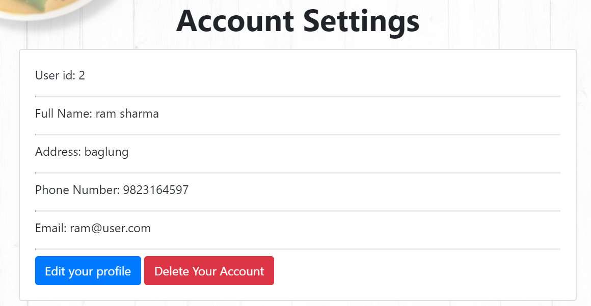

T10

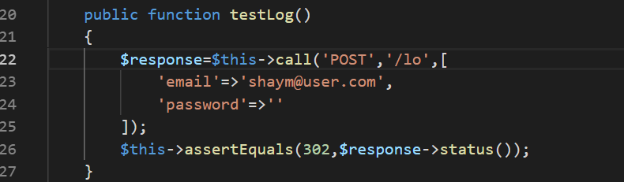

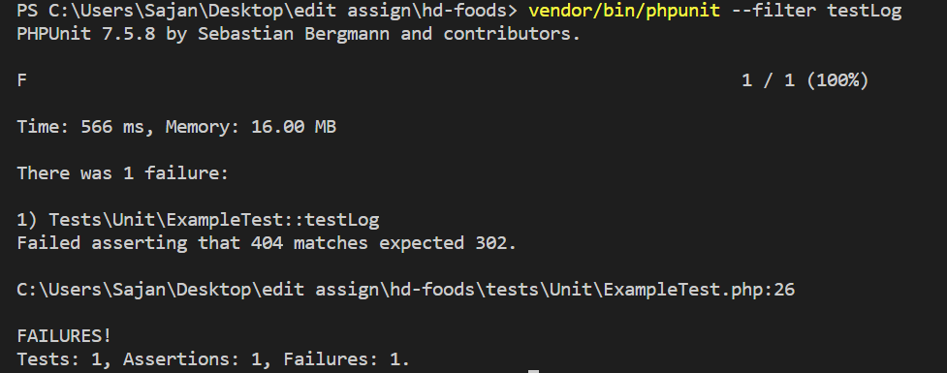

T11

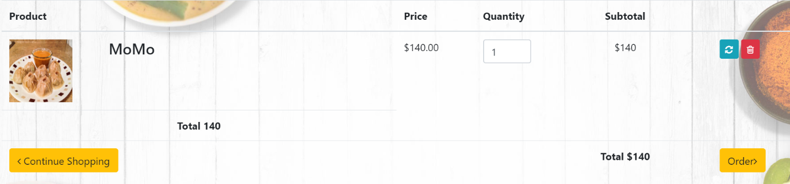

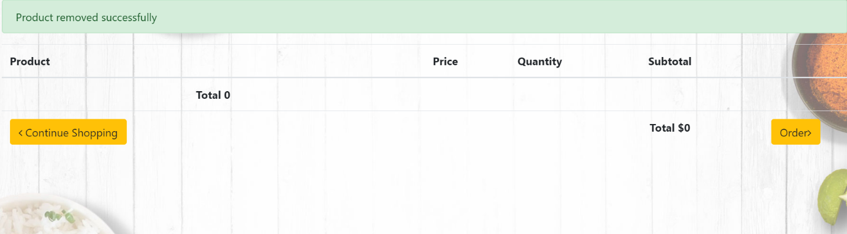

T12

